School Community Intervention Partnership (SCIP)
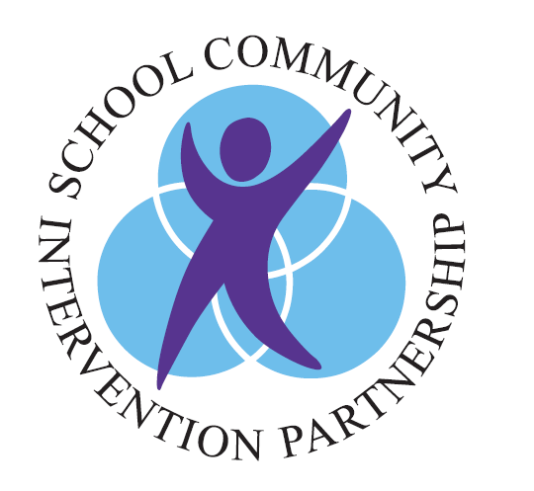

Parent /Guardian Information Sheet

What is SCIP?

SCIP is one of the programs at Vanier Children’s Mental Wellness. It is available in all elementary schools for children in grades 1-5. It helps families with children who are struggling at home, school and / or in the community. Children are more successful when they get help at an early stage. Your child school team can make a referral.

Why SCIP?

Our goal is to support your family. We listen to the views of the family, strengths and challenges. Together we work to achieve positive outcomes. We provide support for referrals and recommendations to services that may benefit your child and family. Although we do not work directly with your child, we work with you to help your child.

How to connect with SCIP

Your child’s school team can complete a Referral Form and send it to SCIP on your behalf.

Once SCIP at Vanier receives the Referral Form, a file will be created for your child.
SCIP team member will contact you to tell you more about SCIP, answer your questions, and schedule an intake appointment.

SCIP is a voluntary program and you can end participation at any point by telling us that you no longer want the service.

Considerations for Diversity and Accessibility

SCIP helps children and families from diverse backgrounds. We want to be accessible, flexible and responsive. We partner with you to understand and respect your family’s individual beliefs and customs. We work with language interpreters when there is a need.

If there are any special considerations you would like us to know about, please tell your SCIP Consultant.

Contact Us
If you are interested in knowing more about SCIP, you can speak with your school’s resource / support worker, or call SCIP directly at 519-432-0881, or email: information@scipinlondon.com.

SCIP is looking forward to working with you.

